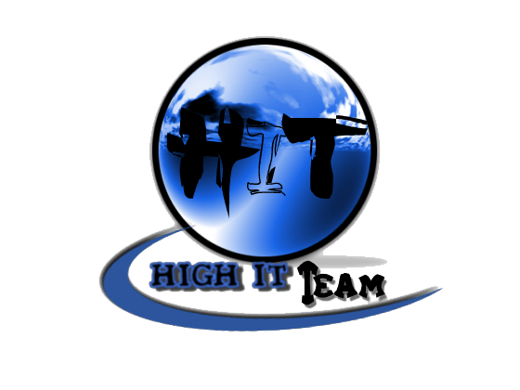
Team Assignment 07
HIT
3/17/2012

Software Measurement and Analysis

Team members: | Members ID
Giang Thị Ha Thanh | T097828
Trần Dũng Đạt | T095716
Nguyễn Vũ Trọng Giang | T096656
Huỳnh Chấn Huy | T096498
Tạ Quang Hiệp | T090363
Nguyễn Trần Hồng Phúc | T095014

• Each team creates a budget for the Viking project, including 4-year NPV, ROI, Payback Period and Breakeven Analysis, and recommends to management whether the Viking product is viable, or not.
- Use the VP Marketing Viking Business Estimates spreadsheet (in the Readings folder) as input to your budget.

- Viking Roadmap

Assumption Roadmap for 4th year of Viking Project and its budget
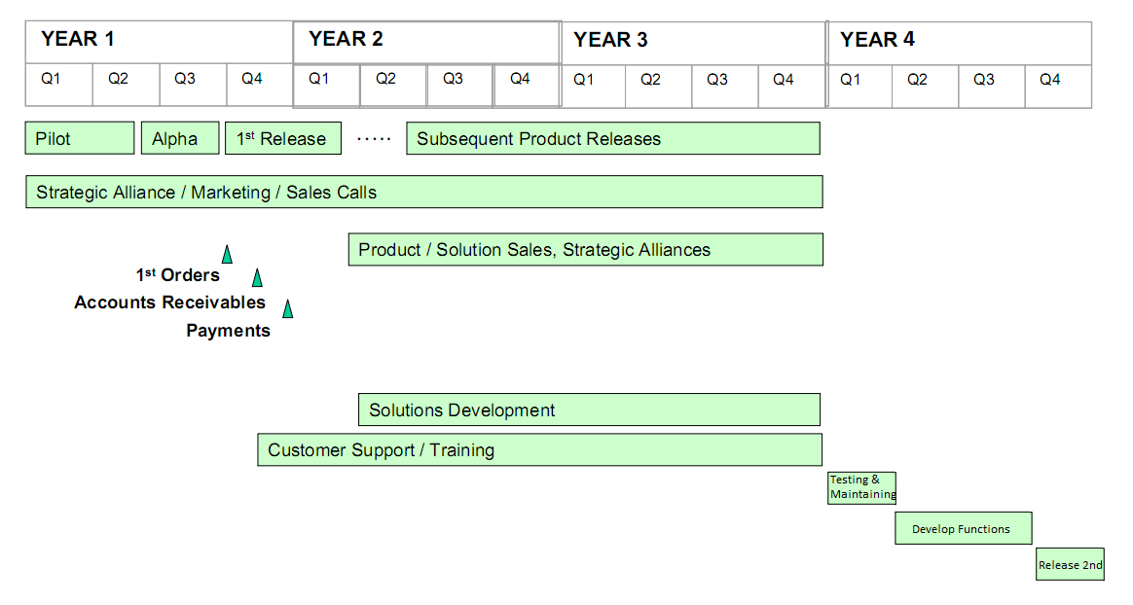
Based on Work Breakdown Structure which developed in the previous team assignment, we propose ​​the charges should be spent on development projects in 4 years.
The first year of the Viking project, investment costs mainly use for system development, costs for changes & risk management, contingency management. The following table estimates the total cost of 1st year:
Year | Category | Detail | Cost ($) | Total
1st year | Developing expense | Salary | 284570 | 536570
1st year | Developing expense | Bonus | 2000 | 536570
1st year | Developing expense | Trainning team | 10000 | 536570
1st year | Developing expense | Travel business | 5000 | 536570
1st year | Developing expense | Team building | 5000 | 536570
1st year | Risk management expense |  | 60000 | 536570
1st year | Change management expense |  | 60000 | 536570
1st year | Equipment (Hardware & Software) |  | 20000 | 536570
1st year | Facility expense |  | 20000 | 536570
1st year | Contingency expense |  | 70000 | 536570
1st year | Training customer | Team Training | 67500 | 536570

On the project budget table, salary paid for developer take large amount. Salary Table below will list the number of developer team participating in the project and for their salary corresponding to their work hours. However, not every member also participate throughout the project, table Salary will based on participate of each member in WBS.

 | Position | Work Hour | Hour Rate | Total Hour | Total Cost | From (month) | To (month)
Year 1 | PM | 2 | 100 | 396 | 39600 | 4 | 12
Year 1 | Developer 1 | 4 | 60 | 528 | 31680 | 6 | 11
Year 1 | Developer 2 | 4 | 60 | 528 | 31680 | 6 | 11
Year 1 | Developer 3 | 4 | 60 | 528 | 31680 | 6 | 11
Year 1 | Developer 4 | 4 | 60 | 528 | 31680 | 6 | 11
Year 1 | Architect | 3 | 150 | 132 | 19800 | 2 | 3
Year 1 | Risk Manager | 2 | 75 | 88 | 6600 | 5 | 6
Year 1 | Change manager | 2 | 75 | 88 | 6600 | 5 | 6
Year 1 | Requirement Engineer 1 | 6 | 75 | 264 | 19800 | 4 | 5
Year 1 | Requirement Engineer 2 | 6 | 75 | 264 | 19800 | 4 | 5
Year 1 | Tester 1 | 3 | 75 | 132 | 9900 | 11 | 12
Year 1 | Tester 2 | 3 | 75 | 66 | 4950 | 12 | 12
Year 1 | Quality Assurance Manager | 2 | 100 | 308 | 30800 | 4 | 10
Total |  |  |  |  | 284570

In 2nd and 3rd it’s the release time, budget cost mostly used for training customer to use the tool and for maintenance product

Year | Category | Detail | Cost ($) | Total
2nd and 3rd year | Maintenance | Team Maintenance | 54000 | 121500
2nd and 3rd year | Training customer | Team Training | 67500 | 121500

According to customer demand, in year 4 project team will develop a number of functions. Development stage lasts from start form Q2 to the end of Q3. On Q4 the product will be release, install, supported.

Year | Category | Detail | Cost ($) | Total
4th year | Maintenance |  | 27000 | 269170
4th year | Developing expense | Salary | 98670 | 269170
4th year | Developing expense | Bonus | 500 | 269170
4th year | Developing expense | Travel business | 1000 | 269170
4th year | Developing expense | Team building | 2000 | 269170
4th year | Risk management expense |  | 20000 | 269170
4th year | Change management expense |  | 20000 | 269170
4th year | Equipment (Hardware & Software) |  | 20000 | 269170
4th year | Facility expense |  | 20000 | 269170
4th year | Contingency expense |  | 60000 | 269170

 | Position | Work Hour | Hour Rate | Total Hour | Total Cost | From (month) | To (month)
Year 4 | PM | 2 | 100 | 132 | 13200 | 4 | 9
Year 4 | Developer 1 | 4 | 60 | 352 | 21120 | 5 | 8
Year 4 | Developer 2 | 4 | 75 | 352 | 26400 | 5 | 8
Year 4 | Risk Manager | 2 | 75 | 44 | 3300 | 4 | 4
Year 4 | Change manager | 2 | 75 | 44 | 3300 | 4 | 4
Year 4 | Requirement Engineer | 6 | 75 | 66 | 4950 | 4 | 4
Year 4 | Tester 1 | 3 | 75 | 132 | 9900 | 9 | 9
Year 4 | Tester 2 | 3 | 75 | 132 | 9900 | 9 | 9
Year 4 | Designer | 3 | 100 | 66 | 6600 | 4 | 4
Total |  |  |  |  | 98670

- Tools to estimate
  - ROI

What is ROI?
ROI (Return on Investment) is a relatively straightforward investment metric that expresses how much time is required (the payback period) to recover the original investment. It may also be expressed as a percentage figure -- ROI%. ROI is calculated as:
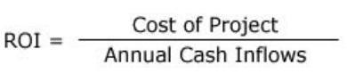

Why is choose ROI?
ROI shows the amount of money you expect to make on a particular investment – and that’s an important thing to know. When you only have a certain amount of money to invest, you’ll want to look at the investment that will return the most money in the shortest amount of time

Total Cost: 927240 $

Viking Revenue Estimates
Viking License Fee | $650
Viking Dev. License Fee | $1.950
Support Fee | 20%

Maximum Total Additional: 3338400
 |  | # Licenses |  |  | # Dev. Licenses |  |  | Volume Discount
 | Company | Year 2 | Year 3 | Year 4 | Year 2 | Year 3 | Year 4 | Volume Discount
Probable (100%) | DefCon USA | 375 | 400 | 550 | 20 | 30 | 40 | 20%
Probable (100%) | Big Communications | 325 | 400 | 550 | 20 | 30 | 40 | 20%
Probable (100%) | Starfleet | 200 | 200 | 350 | 10 | 15 | 25 | 15%
Probable (100%) | Global Energy | 185 | 200 | 350 | 10 | 15 | 25 | 15%
Probable (100%) | Chemicals-R-Us | 55 | 50 | 100 | 5 | 10 | 15 | 15%
 | Additional Viking Licenses | 1185 | 1300 | 2000 | 70 | 110 | 160
 | Additional Revenue from Licenses | $607.100 | $664.625 | $1.014.000 | $103.838 | $159.900 | $232.538
 | Additional Support Revenue | $121.420 | $132.925 | $202.800 | $20.768 | $31.980 | $46.508
 | Total Additional Revenue | $853.125 | $989.430 | $1.495.845

Minimum Total Additional Revenue (80%): 2670720
 |  | # Licenses |  |  | # Dev. Licenses |  |  | Volume Discount
 | Company | Year 2 | Year 3 | Year 4 | Year 2 | Year 3 | Year 4 | Volume Discount
Probable (80%) | DefCon USA | 375 | 400 | 550 | 20 | 30 | 40 | 20%
Probable (80%) | Big Communications | 325 | 400 | 550 | 20 | 30 | 40 | 20%
Probable (80%) | Starfleet | 200 | 200 | 350 | 10 | 15 | 25 | 15%
Probable (80%) | Global Energy | 185 | 200 | 350 | 10 | 15 | 25 | 15%
Probable (80%) | Chemicals-R-Us | 55 | 50 | 100 | 5 | 10 | 15 | 15%
 | Additional Viking Licenses | 1185 | 1300 | 2000 | 70 | 110 | 160
 | Additional Revenue from Licenses | $607.100 | $664.625 | $1.014.000 | $103.838 | $159.900 | $232.538
 | Additional Support Revenue | $121.420 | $132.925 | $202.800 | $20.768 | $31.980 | $46.508
 | Total Additional Revenue | 682500$ | 791544$ | 1196676$

Revenue
 | Year 2 | Year 3 | Year 4 | Total
Maximum Total Additional Revenue (100%) | 853125$ | 989430$ | 1495845$ | 3338400$
Minimum Total Additional Revenue (80%) | 682500$ | 791544$ | 1196676$ | 2670720$

ROI calculation:
 | Total Cost | Total Benefit | ROI (%)
Maximum Total Additional Revenue (100%) | 927240$ | 3338400$ | 260,04%
Minimum Total Additional Revenue (80%) | 927240$ | 2670720$ | 188,02%

We have ROI from 188.02% to 260.04%, it shows that project benefit will increase 2 times of the investment after 3 year released. Compare with the bank interest rate is 14%, we can see Viking project has highly return on investment. We can recover the investment after one year if sell license and Dev. License. So, the successful of Viking project is high.

  - BREAKEVEN ANALYSIS

What is Breakeven Analysis?
Breakeven analysis tells you how much you need to sell/save to break even on your investment (in this case, your project). To make the results clearer, they can be graphed.
It is calculated as:

Why is choose Breakeven Analysis?
Breakeven analysis helps to provide a dynamic view of the relationships between sales, costs and profits

Total cost: 927240

Breakeven analysis calculation:

For Viking License Fee: 650 $
Total Cost | Breakeven analysis
927240 | 1427

For Viking Dev. License Fee: 1950$
Total Cost | Breakeven analysis
927240 | 476

We can see if we sell 1427 license we can recover the investment, based on Viking Marketing Estimates report in the worst case, in 2nd year we can sell 1185 license, so that, we need only more than one year to recover the investment, that a very good sign to see the viability of Viking project.

  - IRR

What is IRR?
IRR (Internal rate of return) is often used in capital budgeting, it is the interest rate that makes net present value of all cash flow equal zero.

Why is choose IRR?
IRR is an indicator of the efficiency, quality, or yield of an investment because the internal rate of return is a rate quantity.
 | Year 1 | Year 2 | Year 3 | Year 4 | IRR
Maximum Total Additional Revenue (100%) | -536570 | 792375 | 928680 | 1226675 | 152%
Minimum Total Additional Revenue (80%) | -536570 | 621750 | 730794 | 927506 | 116%

With Internal rate of return from 116% to 152% compare with discount rate (we choose bank interest rate) is 14%. Profitability of the project can be 9-10 times larger than bank interest rate. Based on the estimated data, this project will be successful with a huge profit.

